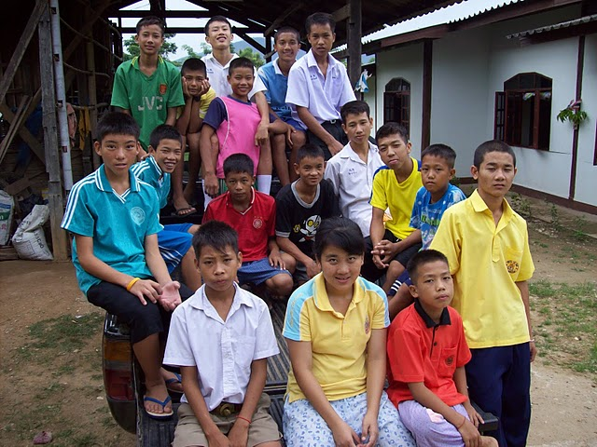
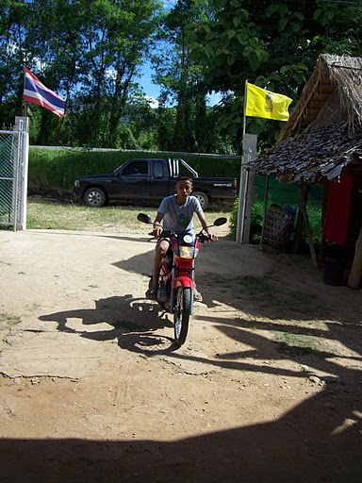

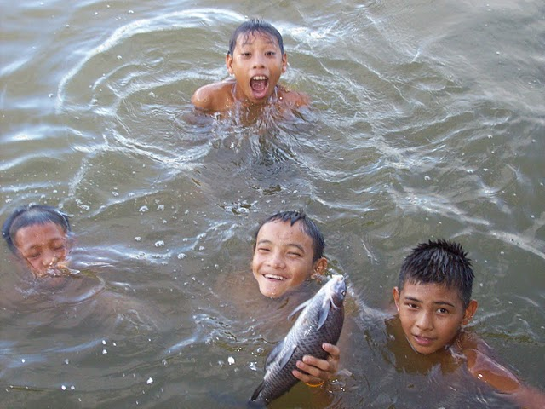



By Cemre Karso
Grade 8
Humanities
9-3-2011
Introduction
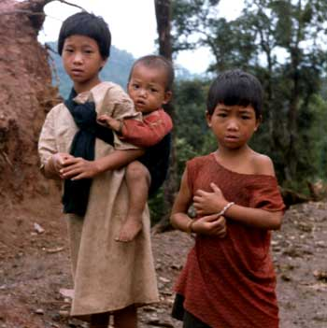
Did you know that more than 1 billion people live on less than $1 a day? Did you know that there are 115 million children who do not attend primary school? Did you know more than 15 million children have lost one or both of their parents because of HIV/AIDS or other diseases? Did you know 2 million children die from infections spread by dirty water or the lack of toilets?
Imagine waking up each morning without enough food to eat, without clean water to drink, without a home. Imagine not being able to spell your own name, having to work to support your family instead of going to school.
Every day we don’t act, people suffer, and they will be poorer and less secure.
We need to act right now and free the world from poverty once and for all.
This project is about how a European saw how life was in Asia.

Table of Contents
- History……………………………………………………………………………………………………………………Page. 3
- Mission and objective statement…………………………………………………………………….Page. 4 & 5
- Projects………………………………………………………………………………………………………………….Page. 6
- Donations………………………………………………………………………………………………………………Page. 7
- Conclusion……………………………………………………………………………………………………………..Page. 8
- Sources………………………………………………………………………………………………………………….Page. 9

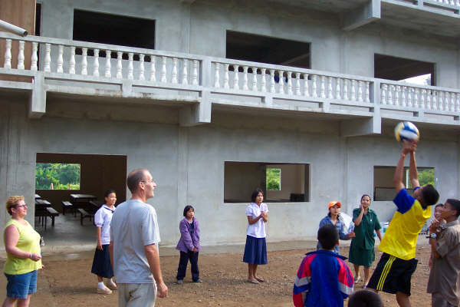

History
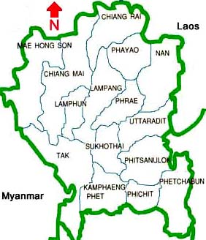
Hill Tribes’ Children is a Dutch foundation founded on 6th May 2008. The foundation was established as an orphanage in Northern Thailand. In addition, it was established to support Thailand financially. The orphanage is called “Mae Taeng” in Pa Mai in northern Thailand. The initiator of the orphanage was Joop Rieff. During his travels in Northern Thailand, he saw many children suffering from poverty, illness, etc. in the area. Mainly in tribes around the mountains (that is where the name came from: “Hill Tribes”). These tribes don’t have anything close to a citizenship and that is why they have only limited access to public services, such as education, healthcare and juridical protection against abuse. Without help, these “hill tribes’ children”, fall in criminal activities.
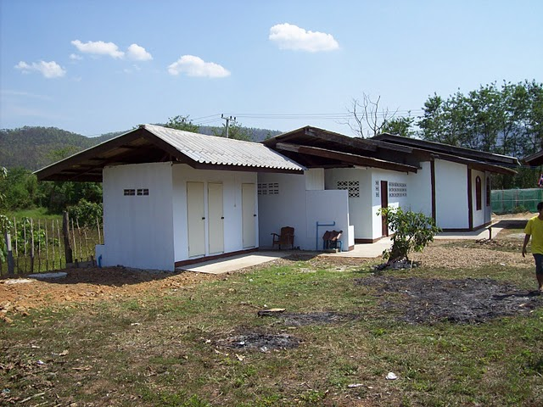
After Joop’s experiences in his travels, he decided to support many other orphanages in Northern Thailand. In 2007, Joop’s plans for a brand new orphanage were finally finished. In early 2007, the new orphanage “Mae Taeng” was established. In order to provide a long term basis for about 20 children, the foundation “Hill Tribes’ Children” was established. After a period of time a school was built to give the children the future chances. The most important thing of the orphanage is to give the children the chance to education and to work on their own futures.
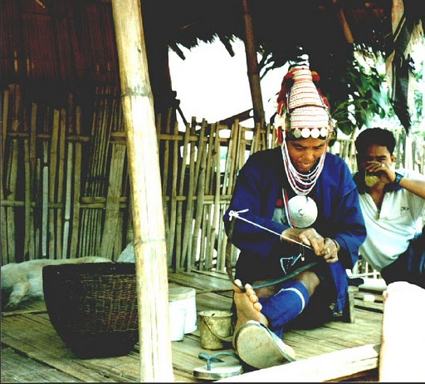
The leadership is carried out by a Lisu, which is a person who lived in an orphanage himself. Joop knows this man from the time he travelled around Thailand, whom he trusted. Joop himself has his responsibility for the guidance and management of the orphanage.

Mission and objective statement
The foundation’s goal is to financially support tribe children in South-East-Asia with their development. Tribe children, mainly orphans or half-orphans, are given the chance to have shelter, nutrition and education mainly in their orphanage. The foundation can only get to its goal by organizing activities (financial) by people in developing countries.
The first goal, to set up the orphanage, was accomplished. A few years after 2008, it was accomplished to get to the budget. The yearly cost of one child in the orphanage is about 500 euros (accommodation, nutrition, clothes, education, etc.). They are currently working on another goal: an investigation to the financial possibilities to expand the orphanage. With the help of donations they can keep on realizing their mission.
Millennium Goals (UN) related to the foundation:
GOAL 1: Eradicate extreme poverty and hunger
The global economic crisis has slowed progress in Thailand. The depth of poverty had reduced in almost every region. More workers find themselves and their families living in extreme poverty.
GOAL 2: Achieve universal primary education
Southern Asia is one of the homes to the huge majority of children out of school. Inequality prevents progress towards universal education.
GOAL 3: Promote gender equality and empower women
Women have it twice as worse than men. Women have to do all the work at homes and girls are not allowed to do a lot of things. Hill Tribes’ Children promotes women.
GOAL 4: Reduce child mortality
Poverty, disease and other things leads to child mortality. Hill Tribes’ Children’s goal was to reduce child mortality.
GOAL 5: Improve maternal health
These children are here because their parents died or that their mothers were not able to take care of their own children. Hill Tribes’ Children is also supporting the villages of the children, by giving the necessary supplies, medicine and food.
GOAL 6: Combat HIV/AIDS and other diseases
A lot of these children’s parents died of diseases. Hill Tribes’ Children is getting all the needs to help people in the villages to prevent disease from happening.
GOAL 7: Ensure environmental sustainability
Hill Tribes’ Children creates a better environment for the villages and the orphanage. By doing this, they can prevent disease from happening. They also bring the cleanest water to the village and the orphanage.
GOAL 8: Develop a global partnership around the world
Hill Tribes’ Children gets international support to improve the villages and the orphanage.

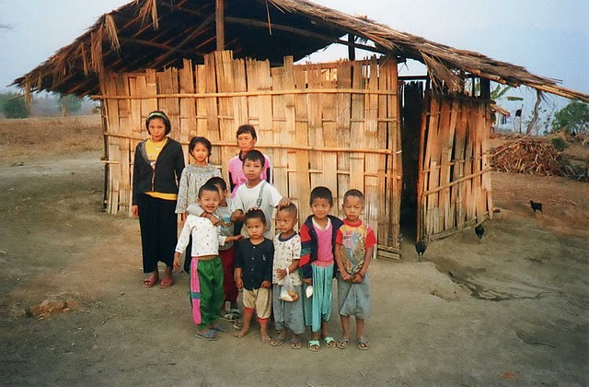

Projects
The Orphanage
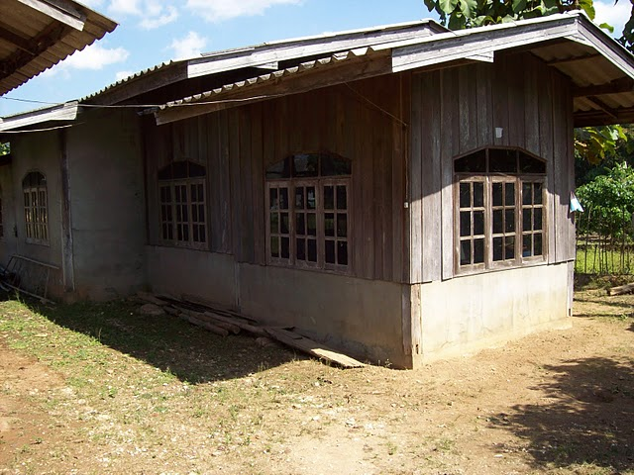
Before the orphanage was established, these children with their poor families where actually on the street without any money. There were some cases that the parents of these children died or were not able to take care of their children. They had to see for themselves how to eat food, get clothes or shelter. Now these children have healthy food and live in a more stable environment. They also learn the necessary skills to escape from a future financial crisis, where they were likely to lose everything. The Millennium Goals related are: Goal 1, 4, 5, 6, 7 & 8.
The School
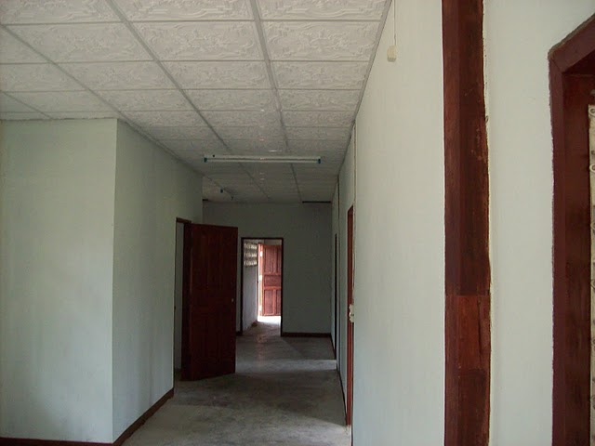
Before the orphanage was established, the parents of these were not able to pay for school or education. They had to learn what their parents learned. The chance to live in the orphanage is the chance to have proper education. Joop supported with building a school nearby the orphanage. When the children are old enough to leave the orphanage, with their education diplomas, they are able to have a spot in society. The empty places are filled by other tribe children. This can continue if we support them and give donations. Recently, 6 children from the orphanage finished their middle school education. Five of them are going to follow extra lessons. The extra lessons are financially supported by Hill Tribes’ Children. The Millennium Goals related are: Goal 2, 3, 7 & 8.
The Atmosphere
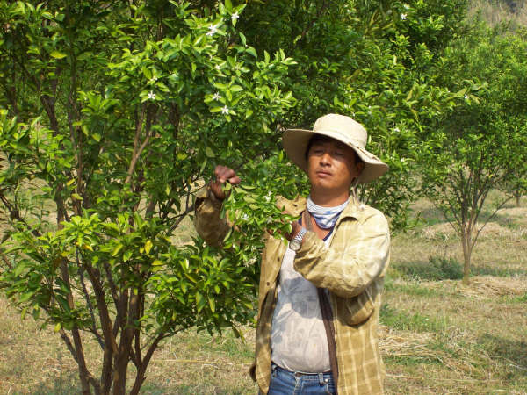
Before the orphanage was established, that part of Thailand was not developed or organized. Joop wanted to give the children a wonderful atmosphere around the orphanage. Firstly, he decided to build an orchard with many different animals. Other than paying for the children’s education, clothes, food and similar means, Joop wanted to make money for the orphanage by planting orange trees. More than 1700 orange trees were planted to make money for the Hill Tribes’ Children. Many people in Thailand and other countries, mainly European, supported the orange trees project. Joop made space around the orphanage for many animals, such as pigs and chickens. He also wanted to have a cornfield to sell and for the pigs and chickens. Half the pigs are used for feeding the children and the other half to sell to make money. The chickens were used to provide eggs and chicken meat. We can also support these projects by giving more donations and keeping these children healthy. The Millennium Goals related are: Goal 1, 7 & 8.
Donations
What you can do!
Support the children in the orphanage Mae Taeng!
You can support the children by giving your donations to the bank account:
4670204
Stichting Hill Tribes’ Children
With your donation, the orphanage can continue/improve.
Start with different fun-raisers or activities!
For questions or more information about the foundation email:
hilltribeschildren@live.nl
Joop Rieff
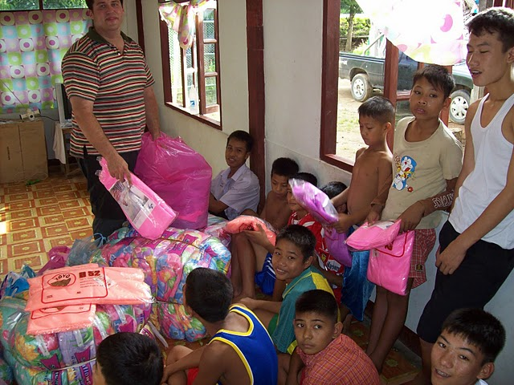
The children in Mae Taeng: Thank you for your support!
Conclusion
Hill Tribes’ Children does everything to help these children in the orphanage. They are given the chance to have shelter, nutrition, education and entertainment. Without Joop’s support and international support these children would not be as happy as they are now. When Joop makes a promise he sticks to his promise. All Joop cares about is the children. The organization has met its objectives and is currently working on expanding the orphanage. I will support the orphanage, because these children should have the chance to be like us.
Before throwing away your unfinished food, you have to consider that poor children around the world need nutrition. Before keeping the water tap on, you have to consider that poor children need water to survive. Before buying your clothes (girls!), you have to consider that if it is necessary to buy this. Can poor children wear this? Before saying school is boring, consider that you should be lucky to have education. Before saying that you don’t want to read, consider that poor children can’t even read.
Support these children! Who knows? They might make history!

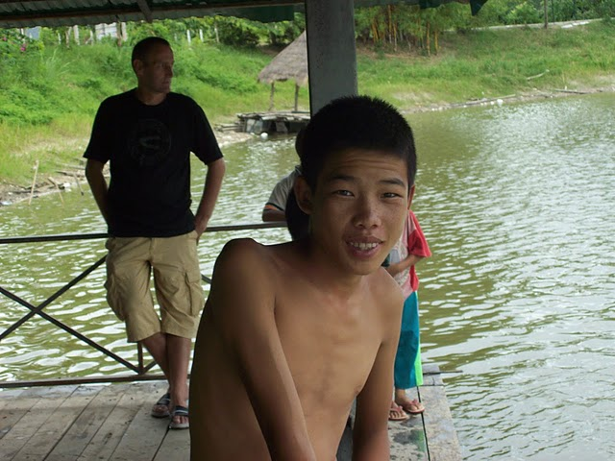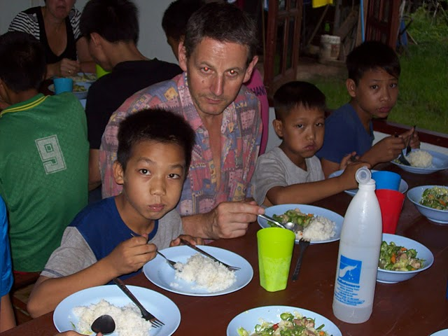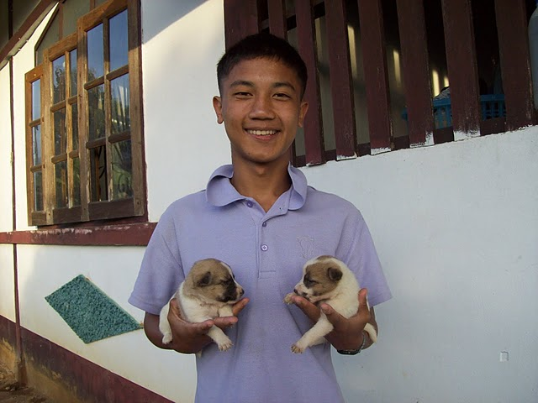
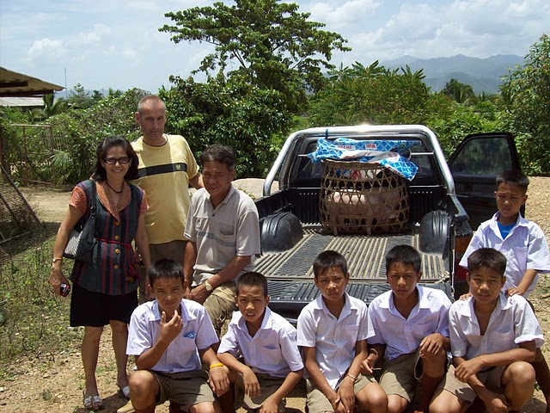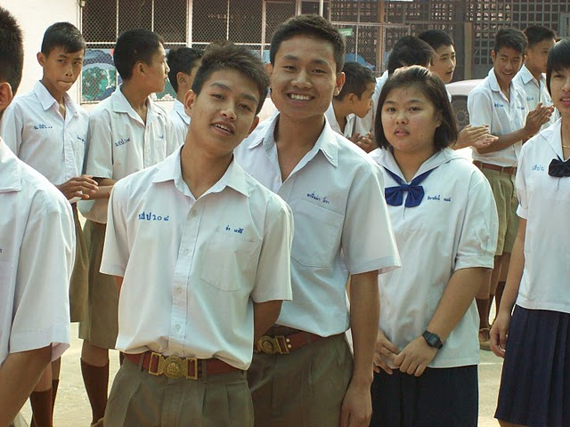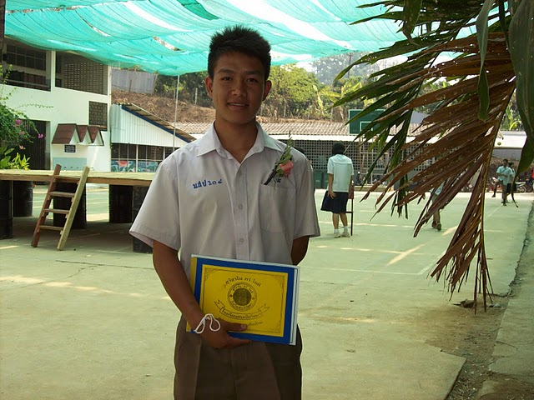
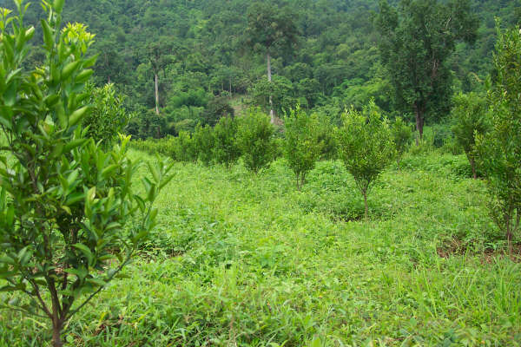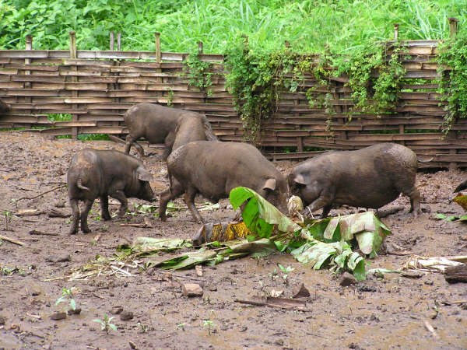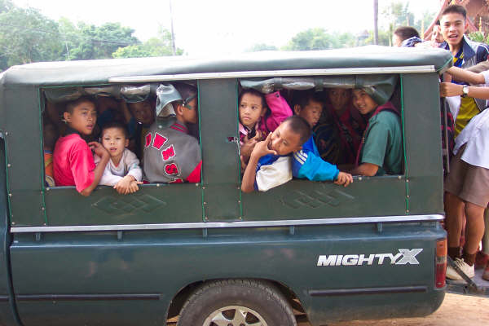
Sources

www.hilltribeschildren.nl

Chairman and my uncle: Johan Hol

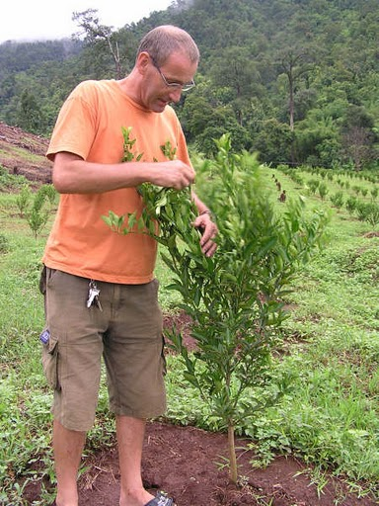
Founder of foundation: Joop Rieff

